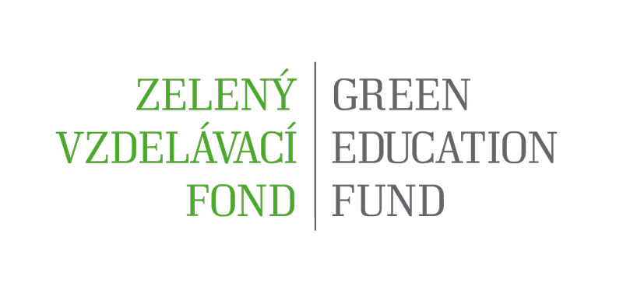

BASIC INFORMATION ON THE FUND

ESTABLISHMENT OF THE GREEN EDUCATION FUND

The Green Education Fund (hereinafter referred to as “GEF” or “the Fund”) is being established attached to the Slovak Environment Agency (hereinafter referred to as “SEA”) based on the decision of the Minister of the Environment of the Slovak Republic on issuing the amendment to the new wording of the foundation deed of the SEA and on issuing the amendment to the new wording of the SEA Statute.

The purpose of the Fund is to support the development of environmental upbringing, education and awareness-raising in the territory of the Slovak Republic through supporting the principles of joint responsibility and direct support for selected activities. The establishment of the Fund enables the pooling and management of funds intended for the fulfilment of the generally beneficial purpose, in particular in the area of the support for environmental education and awareness raising.

The Fund provides support for entities that demonstration at least a 2-year history of activities in environmental education and awareness-raising and have it defined within the statute of enterprise. The following entities can ask for direct support:
- Civic association – in accordance with the Act No. 83/1990 Coll. on Association of Citizens, as subsequently amended
- Associations of legal entities – in accordance with sections 20f - 20j of the Act No. 40/1964 Coll., the Civil Code, as subsequently amended
- Foundation – in accordance with the Act No. 34/2002 Coll. on Foundations and on Change in the Civil Code, as subsequently amended
- Non-profit-making organization providing services of common benefit with the environmental focus – in accordance with the Act No. 213/1997 Coll. on Non-Profit-Making Organizations Providing Services of Common Benefit, as subsequently amended.
Thematic priorities of the second call for proposals from the Green Education Fund:
- Smart, green cities and the transition to a circular economy
- Prevention and mitigation of the adverse impacts of climate change
- Improvement of air quality
- Clean mobility
- The committee of the fund welcomes proposals from donors and potential donors on the inclusion and specification of any other potential and relevant thematic priorities
Activities supported from the Fund are the activities of non-formal environmental education and awareness-raising and of education for sustainable development. The supported activities are as follows: The second call for proposals proposes to support
1. Education and awareness raising activities for children and youth: The support is aimed at the creation and implementation of educational and awareness raising programmes, which support the development of key competencies for sustainable development, as well as the educational goals of the thematic priorities. The fund will support educational activities which utilize experiential, activizing and transformational methodologies. The support is meant for the organizers and implementers of educational projects, programmes, workshops and extra-curricular activities.
2. Educational and awareness-raising activities of lifelong learning, adult learning and of the general and professional public: The support is aimed at the organizers of international, national and regional conferences, symposia, professional seminars, and series of presentations, discussions or courses focusing on the thematic priorities. The support aims to cover costs directly related to the preparation and realization of the above mentioned events, as well as the publication of related materials.
3. Educational and capacity-building activities aimed at coordinators of environmental education, pedagogical employees and youth workers: The goal is to support the educational projects which build competencies for the facilitation of environmental education and education for sustainable development; for the preparation and realization of professional workshops; continuous education; to cover the costs directly related to the preparation and realization of the above mentioned events, as well as the publication of related materials.
The Fund consists of the Fund Commission and Secretariat. The administrative, organizational and professional support for the Fund is integrated in the SEA organizational structure based on the decision of the Minister of the Environment of the Slovak Republic on issuing the amendment to the new wording of the foundation deed of the SEA and on issuing the amendment to the new wording of the SEA statute.
The GEF Commission is a professional body of the SEA established for the purpose of negotiating and selecting project plans and beneficiaries of the EUER support. The Commission is established for the purpose of professional, transparent and independent assessment of project plans.
The Commission consists of the permanent members of the Commission with the general focus and the specialized members of the Commission with the special focus, in dependence on the material character of notification of the support for project plans. All members of the Commission (permanent, specialized) are appointed by the Minister of the Environment of the Slovak Republic. Persons without voting rights can also be invited or called in for the Commission meetings who can comment in a qualified manner on the subject of the Commission meeting in dependence on the material character of the notification of plans.

The GEF Secretariat is the administrative unit founded within the SEA organizational structure defined by the Organizational Regulations of the SEA. The activities of the GEF Secretariat are governed by the manual for support applicants and beneficiaries. The activities of the GEF Secretariat are ensured by the SEA staff. The GEF Secretariat ensures administrative, organizational and professional activities necessary for the fulfilment of the purpose of the Fund´s establishment.

CYCLE OF FUNCTIONING OF THE GREEN EDUCATION FUND

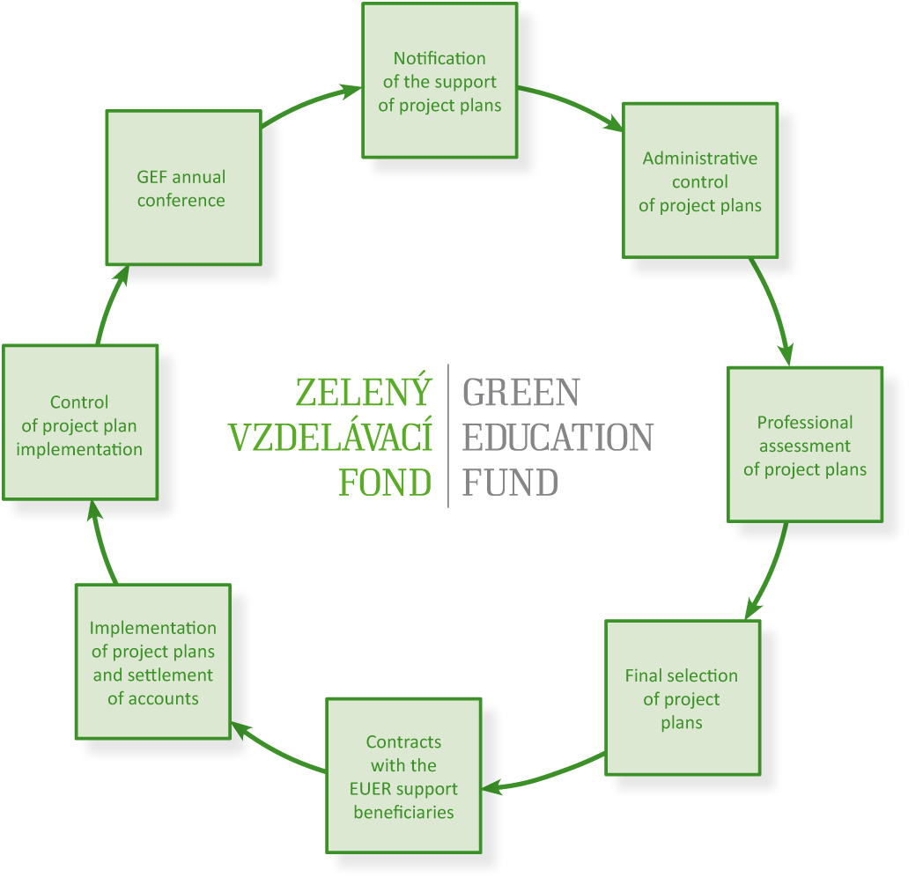

The cycle of functioning of the Green Education Fund is implemented in the following stages:

- Notification of support for project plans – published on the website of the Fund www.zelenyvzdelacifond.sk.

- System of accepting the project plans – it is carried out in the electronic and printed form. The project plan is loaded via the web application, saved after its editing is finished, printed, stamped and signed by the statutory body and at the same time delivered (personally, by mail) within the set deadline to the address of the Fund Secretariat.

- Administrative control of project plans – it is carried out according to the time schedule of the project cycle.

- Expert evaluation of project plans – a project plan meeting the requested conditions of the administrative control is submitted to Specialized Members of the Fund Commission in the electronic form. The expert evaluation includes the individual evaluation of project plans and session of Specialized Members of the Commission in order to approve and submit the list of recommended project plans to convene the Fund Commission Meeting.

- Final selection of project plans – the GEF Commission approves the final list of project plans that will be supported from the GEF. The Minister of the Environment of the SR approves the proposal of the final list of project plans that will be supported from the GEF. If the Minister of the Environment of the SR does not agree with the submitted final list of project plans, he or she can return the list of the GEF Commission with the request for re-negotiation.

- Contracts with beneficiaries of the EUER support – the GEF Secretariat will execute and conclude contracts on provision of funds between the SEA and the EUER support beneficiaries.

- Implementation of project plans and settlement of accounts – the GEF Secretariat shall ensure, based on the contract on provision of funds, releasing funds to the EUER support beneficiaries. The implementation of the project and proper posting is carried out for 12 months or to another exactly defined extent according to the type of notification of project plan support.

- Control of project plan implementation – the GEF Secretariat performs financial, material control of economy, effectiveness, efficiency and purposefulness of the use of provided funds and final financial settlement of provided funds.

- The GEF annual conference- it is held once per year. The annual conference is attended by Members of the Commission, the Commission Secretary and donors (or their authorized representatives) who have provided financial means to the Fund in the monitored period. The annual report will be available on the GEF website.

The cycle of the GEF functioning will be set according to the amount of the Fund’s incomes intended for financing the purpose of the Fund, while it is also possible to flexibly declare more notifications of the support for project plans during one calendar year. Funds provided for the EUER support will also be assigned with respect to the territorial reach of project plan implementation.

FINANCIAL MECHANISM OF THE GREEN EDUCATION FUND
Incomes of the Fund consist of given funds provided on the basis of the contract on purposeful financial gift. Given funds are kept on a special account of the SEA No. SK10 8180 0000 0070 0038 9409 maintained in the State Treasury of the Slovak Republic with the account name: Current Account - the Green Education Fund. All donated financial means the Fund has at its disposal are public financial means in accordance with the Act No. 523/2004 Coll., on Budgetary Rules, as subsequently amended.

The provision of support from the Fund – drawing down financial means from the Fund is subject to the Act No. 343/2015 Coll., on Public Procurement, as amended. The financial means beneficiary is obliged to proceed according to the provisions of section 8 of this Act.

The provision of support from the Fund is carried out based on the contract on provision of funds for the EUER support (hereinafter referred to as the “Contract”) concluded between the SEA and the beneficiaries of funds and after the following conditions are met:

- proving own deposit of the beneficiary in the minimal amount of 5% of the amount of provided funds of the Fund for the support for project plan,
- open current account in a financial institution in the territory of the Slovak Republic, provable with a copy of the contract on opening of the current account,
- statutory declaration certified by notary public that the recipient has not been assigned with any financial contribution from any other programme financed from the state budget or from the state fund for the same purpose of the same subject of enterprise. This statutory declaration does not exclude defining the project plan from the state budget, state fund or any other grant.

The SEA shall provide funds from the account of the Fund after signing the contract and after meeting all the conditions, via cashless transfer to the current account of the recipient of funds. More detailed conditions of provision and take-up of provided funds from the Fund for the support of EUER are specified in the contract.

Control of given funds that were provided to the GEF based on the contract on purposeful financial gift are public funds and are subject to the financial and administrative financial control in accordance with the Act No. 357/2015 Coll. on Financial Control and Audit and on Change and Supplement to Some Acts.

PUBLICITY OF THE GREEN EDUCATION FUND
The GEF Secretariat is responsible for administration and continuous updating of the website of the Fund to the following extent:
- the address of the website of the Fund: www.zelenyvzdelavacifond.sk,
- the basic information of the Fund purpose,
- the Fund logo,
- current information of the support of project plans,
- manual for applicants and beneficiaries of the support of project plans,
- practical advice for completing the application for the support of projects from the Fund,
- frequently asked questions (FAQ),
- web application ensuring the system of receiving and registration of project plans,
- contact details (postal address of the Fund Secretariat, e-mail contact, telephone number),
- promoting of all donors.

Other promotional channels of the GEF:
- promotional materials in the printed form (GEF banner, GEF leaflets, Environmental Journal),
- promotion in the electronic form (the website of the Ministry of the Environment of the Slovak Republic, the SEA, Environmental portal, Facebook/Environmental upbringing, social media),
- promotion of the Fund during independent events (information seminars) and during professional and promotional events organized by the SEA, the Ministry of the Environment of the Slovak Republic and departmental organizations or organizations represented in the Commission of the Ministry of the Environment of the Slovak Republic for the EVVO,
- cooperation with public, commercial and regional media (television, radio, newspaper).

Categorization of donors - by the amount of provided funds to the Fund:
- Platinum partner – provided funds in the amount of more than EUR 50,000.-
- Golden partner – provided funds in the amount of more than EUR 30,000.-
- Silver partner – provided funds in the amount of more than EUR 20,000.-
- Bronze partner – provided funds in the amount of more than EUR 10,000.-
Provision of information is ensured by the Fund Secretariat, while questions must be formulated clearly, distinctly and definitely. Replies to questions sent in writing (by mail, via e-mail) can be considered as binding and it is possible to reply to them. Replies to questions provided by phone or orally cannot be considered as binding and it is not possible to refer to them in the further process. Information is provided in writing or orally through the following:
- Website of the Fund: www.zelenyvzdelavacifond.sk
- E-mail contact: zvf@sazp.sk / boglarka.ivanegova@enviro.gov.sk
- Postal address: GEF Secretariat, SERP SEA, Tajovského 28, 975 90 Banská Bystrica
- Telephone number: 048/43 74 197 or 048/ 43 74 177

