Postup pre komerčných operátorov (slovenských a zahraničných, okrem čínskych)

- Airlines Operating Permit
LInk: http://1.85.12.35:8090/faopss

User name (takes about 1 day):
The airline company authorizes the agent to get an account number, or the airline company directly applies to open an account.
Approval time for the permit: Usually takes 3 days, if all the information and documents are completed, it takes about 2 days.
Process:
Select the non-schedule on the left and download SPECIFIC RULES FOR PERMITTING NON-SCHEDULED OPERATION BY FOREIGN AIR TRASNSPORT ENTERPRISES.pdf
Pay special attention to the terms:
Chapter II, Articles 9 and 10, all required information and documents.
Chapter II, Article 9, point 9, get the airport ground service company contract (service contract), the airport will not sign contract with the Embassy, only with companies. The related marketing department of airport (e.g. business department, business coordination department etc.)
Register or Login: Click “here” to register and or login
Document language: Aircraft-related documents, airline operation certificate, these are all in English; other documents, Chinese or English both is ok, Chinese is preferable.

- Application for the Time & Route
Link: www.pre-flight.cn
Username application: as reference file
Approval time: 24 hours
Application process: Refer to the attachment, fill in the time & route application according to the given space, application for the time and route can be filled online with the permit at the same time, no need to submit documents, after the permit is issued, the approval for time and route will be processed within 24 hours.

Foreign Airlines Operating Permit Supervision System
Link: http://1.85.12.35:8090/faopss
Regulations & Guide: SPECIFIC RULES FOR PERMITTING NON-SCHEDULED OPERATION BY FOREIGN AIR TRANSPORT ENTERPRISES.pdf
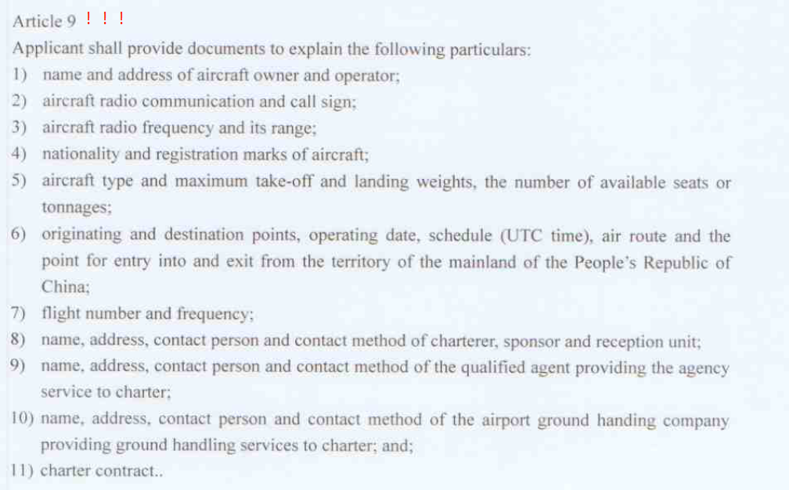
Reference Process:
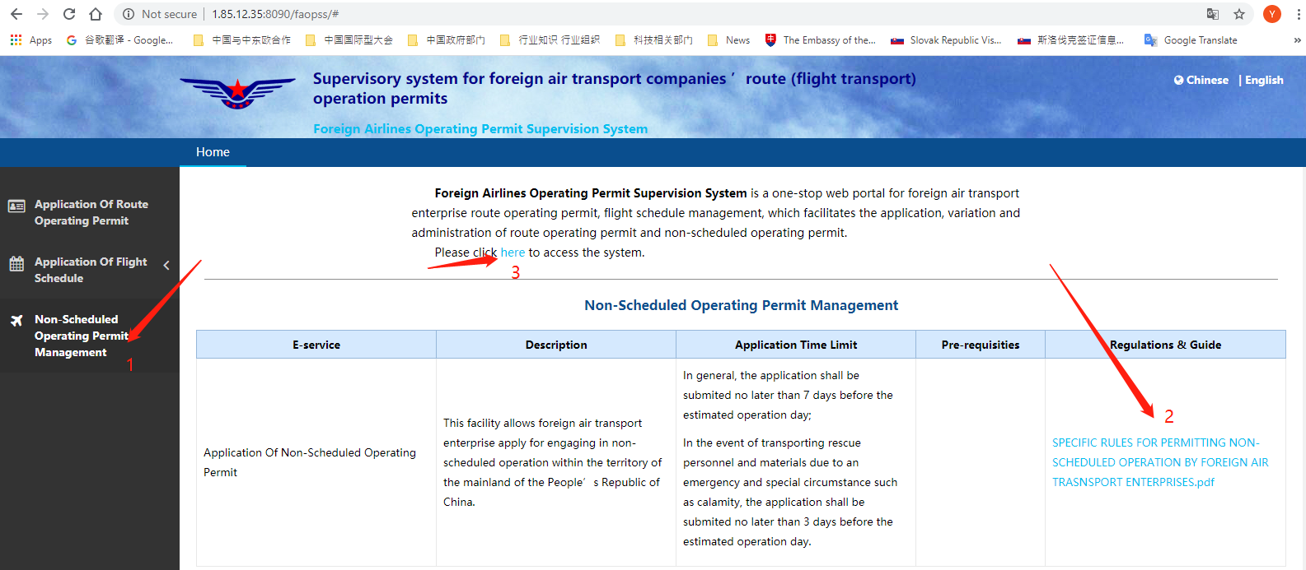

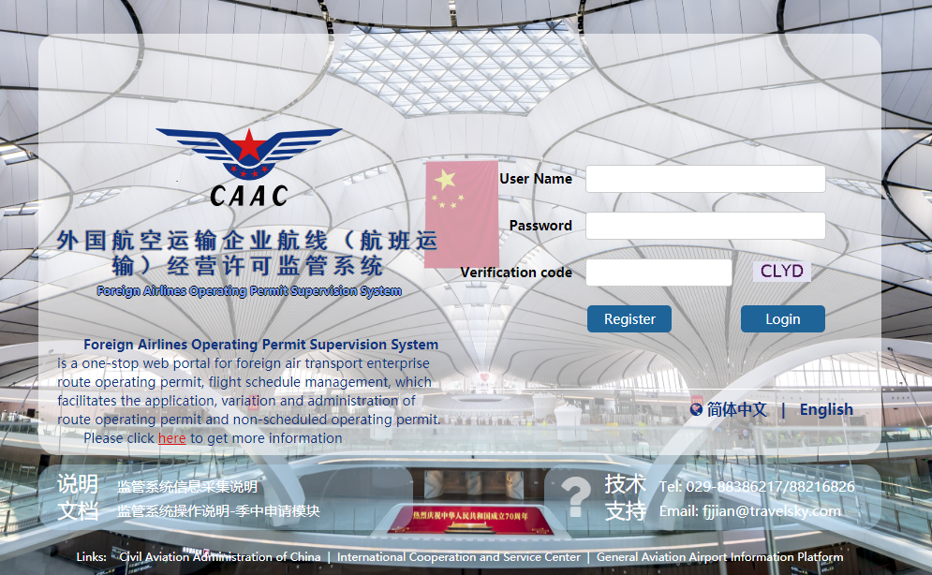
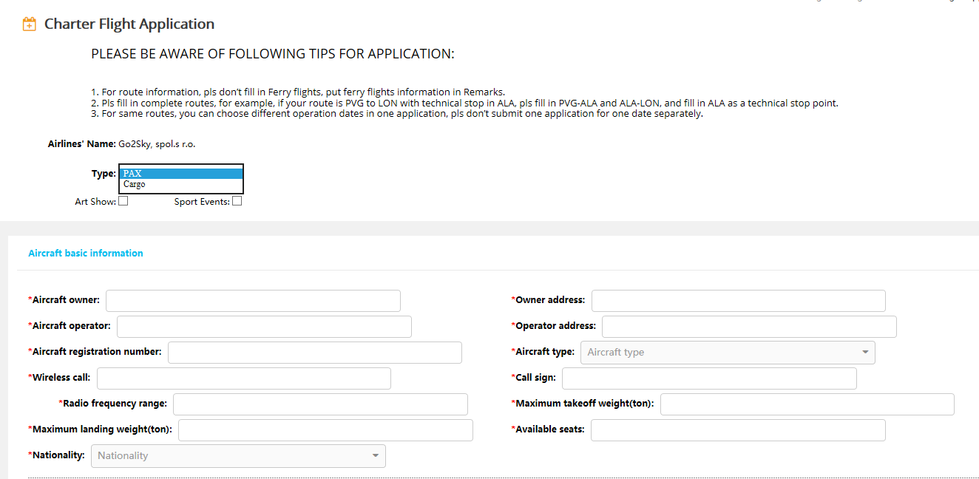

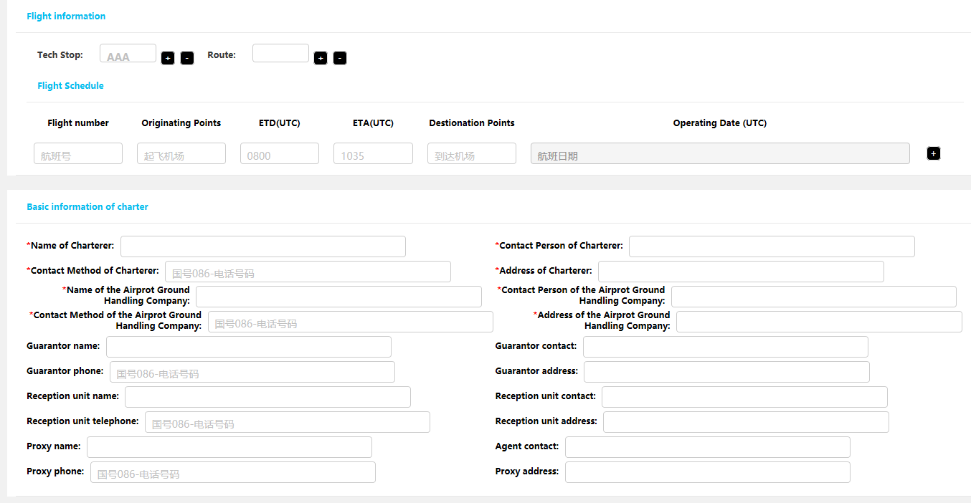

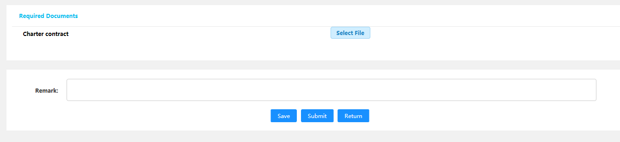

- Application for a pre-flight plan

Link: www.pre-flight.cn
1. Type www.pre-flight.cn in your Brower, Firefox and Chrome are suggested.
2. Log in
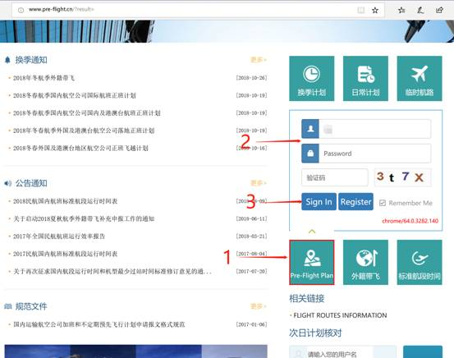
2.1 pls select “Pre-Flight Plan”, then type your username and password;
2.2 For your username and password, pls contact
Tel: 0086-010-82325050, Ext: 6182;
EMAIL：guolk@adcc.com.cn

- The instruction of function
After log in, you can choose the function you need, such as “Scheduled Overflt”, “Nonscheduled Overfly”, “Scheduled landing/departure”, “Nonscheduled landing/departure” and “Route apply for scheduled landing/departure”.
3.1 “Nonscheduled landing and departure” include the application for “Ferry, tech stop, Extra, Charter and test”.
3.2 When you select the function, you can find help document in the right corner.

